 | PERSONALIZED TRAVEL GUIDE BOOKING AND ASSISTANCE PLATFORM | 
A PROJECT REPORT
Submitted by

KAROLINA A 811722104069
MUBINA BEGUM M 811722104094
RANJANI S 811722104121

in partial fulfillment of the requirements for the award degree of
Bachelor in Engineering

20cs7503 & DESIGN PROJECT – III

DEPARTMENT OF COMPUTER SCIENCE AND ENGINEERING
k. rAMAKRISHNAN cOLLEGE OF technology
(AUTONOMOUS)
SAMAYAPURAM - 621112

NOVEMBER 2025

PERSONALIZED TRAVEL GUIDE BOOKING AND ASSISTANCE PLATFORM
A PROJECT REPORT
Submitted by

KAROLINA A 811722104069
MUBINA BEGUM M 811722104094
RANJANI S 811722104121

in partial fulfillment of the requirements for the award degree of
Bachelor in Engineering

20cs7503 & DESIGN PROJECT – III

DEPARTMENT OF COMPUTER SCIENCE AND ENGINEERING
k. rAMAKRISHNAN cOLLEGE OF technology
(AUTONOMOUS)
SAMAYAPURAM - 621112

NOVEMBER 2025

k.rAMAKRISHNAN cOLLEGE OF technology
(AUTONOMOUS)
SAMAYAPURAM - 621112

Bonafide CERTIFICATE
The work embodied in the present project report entitled “PERSONALIZED TRAVEL GUIDE BOOKING AND ASSISTANCE PLATFORM” has been carried out by the student KAROLINA A(811722104069),MUBINA BEGUM M (811722104094), RANJANI S (811722104121) The work reported herein is original and we declare that the project is their own work, except where specifically acknowledged, and has not been copied from other sources or been previously submitted for assessment.
Date of Viva Voce: ……………………

Mr. M.A. Prasanna, B.E., M.Tech.  SUPERVISOR  Assistant Professor  Department of CSE  K. Ramakrishnan College of Technology  (Autonomous)  Samayapuram – 621 112. | Mr. R. Rajavarman, M.E.,(Ph.D.)  HEAD OF THE DEPARTMENT  Assistant Professor (Sr. Grade)  Department of CSE  K. Ramakrishnan College of Technology (Autonomous)  Samayapuram – 621 112.

internal eXAMINER EXTERNAL EXAMNIER
ABSTRACT
The project aims to create an application as a guide for tourists to visit the tourist sites. A digital platform called the Online Tourist Guide Booking System was created to link tourists with qualified tour guides, providing a smooth and customized travel experience. Users can search and reserve tour guides using this system according to availability and location. The objective of the Tourist Guide Management System is to modernize and streamline the traditional methods of managing tour guides and booking processes. This smart system replaces manual, paper-based methods, offering a faster, more reliable, and user-friendly solution. Tourists can easily search for and book qualified guides based on their preferences, such as location, language, and expertise. The system ensures that guides can efficiently manage their availability, accept or decline bookings, and track their schedules in real- time. Additionally, the system allows travel agencies to monitor all operations, optimize guide allocation, and generate reports on bookings and customer satisfaction. By automating processes, improving communication, and reducing manual errors, the Tour Guide Booking System aims to enhance the overall tourism experience for both tourists and guides while increasing operational efficiency.

Keywords: Location Tracking, Route Planning, Attraction Finder, Real-Time Navigation, Recommendation Engine, Geo-Tag Mapping, Travel Assistance

ACKNOWLEDGEMENT

We thank our Dr. N. Vasudevan, Principal, for his valuable suggestions and support during the course of my research work.
We thank our, Mr. R. RAJAVARMAN, Head of the Department, CSE for his valuable suggestions and support during the course of my research work.
We wish to record my deep sense of gratitude and profound thanks to my Guide, Mr. M.A. PRASANNA, Department of CSE for his keen interest, inspiring guidance, constant encouragement with my work during all stages, to bring this thesis into fruition.
We are extremely indebted to our project coordinator, Mr. M. SARAVANAN, Department of CSE for his valuable suggestions and support during the course of my research work.
We also thank the faculty and non-teaching staff members of the, Department Computer Science and Engineering, K Ramakrishnan College of Technology, Samayapuram, for their valuable support throughout the course of my research work.
Finally, we thank our parents, friends and our well wishes for their kind support.

Signature

TABLE OF CONTENTS
CHAPTER | TITLE | PAGE No.
 | ABSTRACT | iii
 | LIST OF FIGURES | vii
 | LIST OF ABBREVIATIONS | viii
1 | INTRODUCTION | 1
 | - Background | 1
 | - Objective | 1
 | 1.3 Overview | 2
 | 1.4 Problem Statement | 3
 | 1.5 Implication | 3
2 | LITERATURE SURVEY | 5
3 | EXISTING SYSTEM | 11
 | 3.1 Introduction | 11
 | 3.2 Block Diagram of Existing System | 12
4 | PROBLEMS IDENTIFIED | 13
5 | PROPOSED SYSTEM | 16
 | 5.1 Block Diagram of Proposed System | 17
6 | SYSTEM DESIGN | 19
 | 6.1 Usecase Diagram | 19
 | 6.2 Class Diagram | 20
 | 6.3 Sequence Diagram | 20
 | 6.4 Component Diagram | 21
 | 6.5 Deployment Diagram | 22
 | 6.6 Architecture Diagram | 23
7 | SYSTEM REQUIREMENTS | 24
 | 7.1 Hardware Requirements | 24
 | 7.2 Software Requirements | 24
8 | SYSTEM IMPLEMENTATIONS | 25
 | 8.1 List of Modules | 25
 | 8.1.1 UserRegistration & Authentication Module | 25
 | 8.1.2 Guide Profile Management Module | 25
 | 8.1.3 Tour Management Module | 26
 | 8.1.4 Booking & Reservation System Module | 27
 | 8.1.5 Review & Rating Module | 28
9 | RESULTS AND DISCUSSION | 29
 | 9.1 Result and Discussion | 29
 | 9.2 Performance of Guide Search and Matching | 29
 | 9.3 Booking Execution and Response Handling | 30
 | 9.4 User interface output and Interaction | 30
 | 9.5 Comparison with Traditional Guide Booking Methods | 30
 | 9.6 System Accuracy and Limitations | 31
 | 9.7 Overall Discussion | 31
10 | CONCLUSION AND FUTURE WORK | 32
 | 10.1 Conclusion | 32
 | 10.2 Future Enhancements | 32
 | APPENDIX A - SOURCE CODE | 34
 | APPENDIX B - SCREENSHOTS | 52
 | REFERENCES | 56
 | LIST OF PUBLICATIONS (If any) | -

LIST OF FIGURES

FIGURE No. | FIGURE NAME | PAGE No.
3.1 | Existing Diagram | 12
5.1 | Proposed Diagram | 18
6.1 | Usecase Diagram | 19
6.2 | Class Diagram | 20
6.3 | Sequence Diagram | 21
6.4 | Component Diagram | 22
6.5 | Deployment Diagram | 23
6.6 | Architecture Diagram | 23
B.1 | Home Page | 52
B.2 | Guide Registration | 52
B.3 | Guide Login | 53
B.4 | User Login | 53
B.5 | Book Guide | 54
B.6 | Reservation | 54
B.7 | Feedback | 55

LIST OF ABBREVIATIONS

ABBREVIATION | FULL FORM
NLP | - Natural Language Processing
SQL | - Structured Query Language
AI | - Artificial Intelligence
LLMs | - Large Language Models
RAG | - Retrieval Augmented Generation
NL | - Natural Language
VS | - Visual Studio Code
ORM | - Object Relational Mapper
CRUD | - Create, Read, Update, Delete

CHAPTER 1
INTRODUCTION

1.1 BACKGROUND
In this fast-paced world, tourism is a vibrant and dynamic industry that is constantly evolving to meet the diverse needs and desires of travelers around the world. With the advent of technology and the internet, traveling has become easier than ever before, allowing people to explore new places, cultures and experiences more easily than ever before. This shift is not only changing the way people perceive and participate in travel, it is also having a major impact on all aspects of society, from business and culture to sustainability and international trade. The internet serves as a gateway to more travel information and services, giving travelers more resources to plan, book and enhance their trips.

1.2 OBJECTIVE
In Natural Language to SQL Data project is to simplify the process of database interaction by allowing users to communicate with databases using natural language instead of traditional SQL commands. This system aims to eliminate the technical barriers faced by non-programmers and enable them to perform database operations easily through plain text queries. It focuses on leveraging Natural Language Processing (NLP) and Artificial Intelligence (AI) techniques to accurately interpret user intent and translate it into executable SQL statements. The project strives to make data access more inclusive, intuitive, and efficient by bridging the gap between human language and structured query syntax. It also aims to enhance the usability of database systems by integrating Retrieval Augmented Generation (RAG) and the OLLAMA API for precise and context-aware SQL generation. Additionally, the project seeks to improve decision-making by transforming raw data into meaningful insights that can be easily understood and analyzed. Ultimately, the objective is to democratize data access, empower users without technical expertise, and create a user-friendly platform that supports all essential database operations such as Create, Read, Update, and Delete (CRUD) through simple natural language interaction.

1.3 OVERVIEW
Natural Language to SQL Data project provides an intelligent solution for simplifying database communication through natural language processing. The system is designed to understand user queries written in plain English and convert them into accurate SQL commands that can be executed on a database. This approach removes the need for users to have prior knowledge of SQL syntax or database structures, making data interaction more accessible and efficient. The system architecture consists of multiple integrated modules including the Database Module, User Interface Module, Analyze Module, NLP-to-SQL Module, and CRUD Module each responsible for specific operations such as data management, user communication, language processing, and query execution. It uses Python, Streamlit, and SQLAlchemy for backend processing, while OLLAMA API and Retrieval Augmented Generation (RAG) techniques are employed for translating natural language into structured SQL queries with high accuracy. The user interface provides a simple and interactive environment where users can input text, view generated SQL queries, and see results instantly. This project not only enhances usability but also promotes data democratization, allowing non-technical users to analyze and manage data independently. By combining artificial intelligence with database systems, the project delivers a powerful, user-friendly, and efficient platform for intelligent data access and manipulation. This approach removes the need for users to have prior knowledge of SQL syntax or database structures, making data interaction more accessible and efficient. The user interface provides a simple and interactive environment where users can input text, view generated SQL queries, and see results instantly.

1.4 PROBLEM STATEMENT
In conventional database systems, users are required to have a thorough understanding of Structured Query Language (SQL) to retrieve, update, or analyze data. This creates a significant barrier for non-technical users who lack programming or database expertise, making them dependent on technical personnel for even simple operations. Writing accurate SQL queries demands knowledge of table structures, relationships, and syntax, which often leads to human errors, inefficiency, and time delays. Additionally, existing systems do not support natural language interaction, forcing users to rely on manual query construction that can be complex and error-prone. With the increasing demand for data-driven decision-making, there is a growing need for a system that can understand human language and translate it into structured SQL queries automatically. Therefore, the main problem addressed in this project is the lack of an intelligent, user-friendly interface that allows users to communicate with databases using natural language. The system must bridge the gap between human language and database operations, reduce technical dependency, and enhance accessibility, accuracy, and efficiency in data interaction. Additionally, the project seeks to improve decision-making by transforming raw data into meaningful insights that can be easily understood and analyzed. Ultimately, the objective is to democratize data access, empower users without technical expertise, and create a user-friendly platform that supports all essential database operations such as Create, Read, Update, and Delete (CRUD) through simple natural language interaction.

1.5 IMPLICATION
The Natural Language to SQL Data system has significant implications in the field of data management and accessibility. By integrating Natural Language Processing (NLP) and Artificial Intelligence (AI), the system transforms the way users interact with databases, making data retrieval and manipulation possible through simple natural language queries. This approach removes the dependency on technical experts and empowers non-technical users such as business analysts, managers, and students to independently access and analyze data. It contributes to the democratization of data, allowing organizations to make faster and more informed decisions without waiting for database administrators. The system’s intelligent design also reduces the time spent on query formulation, minimizes errors, and enhances overall productivity. Furthermore, it can be implemented in sectors like education, healthcare, finance, and e-commerce where large volumes of data are processed daily. The project also lays the foundation for future research in AI-driven database systems, potentially integrating voice-based queries or multi-language support. Overall, this project has the potential to revolutionize database accessibility by combining human language understanding with machine intelligence to create smarter, faster, and more inclusive data systems.

CHAPTER 2
LITERATURE SURVEY

1) Big Data for Personalized Tour Guide Recommendations, Chen, L., Zhang, Y., Wang, X, 2021.
The paper "Big data for personalized tour guide recommendations" by Chen, L., Zhang, Y., and Wang, X., published in 2021, delves into the application of big data analytics to create a personalized tour guide recommendation system. The system leverages a variety of data sources, including social media, user reviews, and location-based data, to gain a deep understanding of individual user preferences and interests. By employing advanced machine learning techniques, the system can effectively predict user needs and generate highly tailored tour recommendations. A key aspect of this system is its ability to incorporate real-time feedback. As users interact with the recommendations and provide feedback, the system continuously learns and adapts, refining its suggestions to better align with user preferences. This iterative process ensures that the recommendations remain relevant and engaging over time.

2) Mobile Based Tourist Guide Booking System, Singh .S., Patel. A, 2018.
The paper "Mobile-based tourist guide booking system" by Singh, S., and Patel, A., published in 2018, proposes a mobile application to streamline the process of hiring local tour guides. The system aims to connect tourists with qualified guides, providing a convenient platform for booking and managing tours directly from their mobile devices. Key features of the system include user registration and authentication, guide profiles with detailed information and ratings, real-time tour availability and booking, secure online payment integration, and a messaging system for communication between tourists and guides.
3) User Experience in Online Guide Booking Platforms, Patel, M., Kaur, R., 2020.
The paper "User Experience in Online Guide Booking Platforms" by Patel, M., and Kaur, R., published in 2020, explores the factors that influence user satisfaction and loyalty on online guide booking platforms. Through a comprehensive literature review and empirical study, the authors identify key determinants of user experience. The study reveals that ease of use, information quality, and perceived value significantly impact user satisfaction. A user-friendly interface, clear and concise information, and a fair pricing structure are essential for a positive user experience. Additionally, the role of trust and security in online transactions is highlighted. Users are more likely to trust and use a platform if they perceive it as secure and reliable.

4) Impact of User Reviews in Guide Booking, Kumar, V., Agarwal, N., 2021.
The paper "Impact of User Reviews in Guide Booking" by Kumar, V., and Agarwal, N., published in 2021, explores the significant role of user reviews in influencing guide booking decisions. In today's digital age, where online platforms dominate the travel industry, user reviews have become a crucial factor for travelers in making informed choices. The study delves into how various aspects of user reviews, such as quantity, sentiment, and recency, impact user perception and booking intentions. The research findings indicate that a higher number of positive reviews significantly increases the likelihood of a guide being booked. Additionally, the recency of reviews plays a vital role, with recent positive reviews having a greater impact on user decisions. This suggests that tour operators and guides should actively encourage and manage user reviews to maintain a positive online reputation. Overall, the study emphasizes the power of user reviews in shaping the success of guide booking platforms. By understanding the impact of user reviews, tour operators and guides can leverage this valuable resource to attract more customers and build a strong online presence.
5) Social Media Integration in Guide Booking, Zhang, P., Lee, H., 2022.
The paper "Social Media Integration in Guide Booking" by Zhang, P., and Lee, H., published in 2022, explores the potential of integrating social media into guide booking platforms. By leveraging the vast amount of user data available on social media platforms, such as preferences, interests, and online behavior, these platforms can enhance user experience, increase engagement, and facilitate personalized recommendations. The integration of social media data allows for a deeper understanding of user needs and preferences. By analyzing user profiles, posts, and interactions, the system can identify relevant interests and suggest tours that align with their preferences. This personalized approach can significantly improve user satisfaction and encourage repeat bookings.

6) Tourism Booking Systems: A Review of Technologies and Challenges Fernandez, M., Martinez, J., 2020.
The paper "Tourism Booking Systems: A Review of Technologies and Challenges" by Fernandez, M. and Martinez, J., published in 2020, provides a comprehensive overview of the technological advancements and challenges associated with modern tourism booking systems. The authors delve into the various technologies that have transformed the tourism industry, including artificial intelligence, machine learning, and big data analytics. These technologies have empowered tourism booking systems to offer personalized recommendations, optimize pricing strategies, and improve overall customer satisfaction. By leveraging AI and machine learning algorithms, these systems can analyze vast amounts of data to understand user preferences, predict future trends, and deliver tailored experiences. The paper concludes by emphasizing the need for continued research and development in the field of tourism. . These technologies have empowered tourism booking systems to offer personalized recommendations, optimize pricing strategies, and improve overall customer satisfaction.
7) Intelligent Tour Guide Recommendation using Machine Learning
Rahman, A., Yadav, S., 2019.
The paper introduces a machine-learning-based framework for predicting the most suitable tour guides for users by analysing their interests, travel patterns, and historical behaviours. Traditional recommendation systems struggle to capture changing user preferences, but this study demonstrates how machine learning models can adapt dynamically to evolving user behaviour. The authors also highlight how sentiment analysis from user feedback improves the accuracy of predictions by incorporating subjective evaluations of guides and destinations.
Furthermore, the study emphasizes the importance of hybrid recommendation methods that combine demographic data, contextual information, and behaviour-based analytics. The paper explains that reinforcement learning can continuously refine recommendations as more interactions occur, allowing the system to "learn" user habits. The authors also highlight the scalability of ML-based tourism systems, which can handle large datasets and millions of user-guide interactions efficiently. Overall, the integration of machine learning significantly enhances personalization and user satisfaction in tourism guide booking platforms.

8) A Secure and Scalable Cloud-Based Tourism Management Platform Devi, R., Kumar, B., 2020.
This research proposes a cloud-enabled tourism management system designed to support large-scale booking, guide management, payment processing, and user data storage. Emphasizing scalability, the authors highlight how cloud-based architecture can manage high user demand during peak travel seasons without compromising performance. The system uses distributed data storage, load balancing, and end-to-end encryption to provide high security and reliability.
The paper further explains that cloud-based solutions allow travel platforms to deploy updates rapidly, integrate new features seamlessly, and ensure business continuity through automated backup and disaster recovery systems. The use of advanced authentication protocols and secure APIs helps protect sensitive user information from unauthorized access. The authors also highlight how real-time monitoring tools in cloud platforms help detect threats, optimize performance, and ensure seamless user experience. The study concludes that cloud computing is an essential backbone for modern, flexible, and secure tourism booking systems.

9) Real-Time Location Tracking for Tourism Assistance Systems Nakamura, K., Sun, D., 2021.
This paper examines the integration of real-time GPS tracking and geospatial analytics to enhance communication and coordination between tourists and guides. The system provides live updates on the guide’s movement, enabling tourists to locate meeting points easily and avoid delays. A hybrid positioning model that combines GPS, Wi-Fi, and sensor data ensures accurate location detection even in crowded urban areas or partially indoor environments. The research also proposes geofencing mechanisms to trigger alerts when users enter or exit predefined tourist zones. The authors highlight that this technology enhances safety, reduces confusion, and supports smoother navigation. The paper also explores energy-efficient tracking methods to help conserve battery life on mobile devices an important factor for long tours. By integrating mapping APIs and predictive routing, the system can recommend alternate pathways, estimate travel times, and provide congestion alerts. These features make real-time location tracking an essential addition to modern tourism platforms.

10) Enhancing Trust in Digital Tourism Platforms through Review Analytics Sharma, T., Bose, R., 2022.
The study focuses on the critical role of user reviews in influencing decision-making on guide booking platforms. The authors note that fake or manipulated reviews can mislead users, damage platform credibility, and negatively impact overall user satisfaction. To address this, the paper proposes an NLP-driven review analysis system capable of identifying suspicious patterns, sentiment exaggeration, and repetitive language that may indicate fake reviews.
The research further demonstrates that emotional tone detection within reviews helps understand user sentiment beyond numerical ratings. The authors recommend implementing verified review systems and reviewer activity tracking to increase transparency and accountability. Combining review analytics with guide performance metric such as punctuality, communication quality, and responsiveness creates a more comprehensive evaluation mechanism. The paper concludes that strong review validation mechanisms significantly boost user trust, platform loyalty, and booking frequency.

CHAPTER 3
EXISTING SYSTEM
3.1 INTRODUCTION
The current manual technique for scheduling tour guides is frequently laborious and ineffective. Generally speaking, travelers depend on word-of-mouth referrals, travel agencies, or on-the-spot employment in tourist destinations. These approaches are not standardized and frequently lead to fewer options because travelers do not have access to comprehensive details about the guides, such as their training, experience, or language skills. Inconsistent communication between tour guides and passengers may also result in miscommunications or schedule issues. Furthermore, manual booking methods lack a review or feedback mechanism, which makes it challenging for travelers to evaluate the caliber of services in advance. Cash is frequently used for payments, which can be difficult and subject to disagreements. All things considered, the manual approach is opaque, unreliable, and inconvenient, which presents problems for both tourists and tour operators.
DISADVANTAGES OF EXISTING SYSTEM
• The procedure typically calls for face-to-face negotiations or the use of travel agencies, both of which can be rigid and time-consuming.
• There is no established method to confirm the guide's qualifications or dependability, which could cause problems with confidence.
• In the absence of a centralized system, miscommunications or scheduling problems may result from the coordination and communication between guides and travelers.

3.2 BLOCK DIAGRAM OF EXISTING SYSTEM
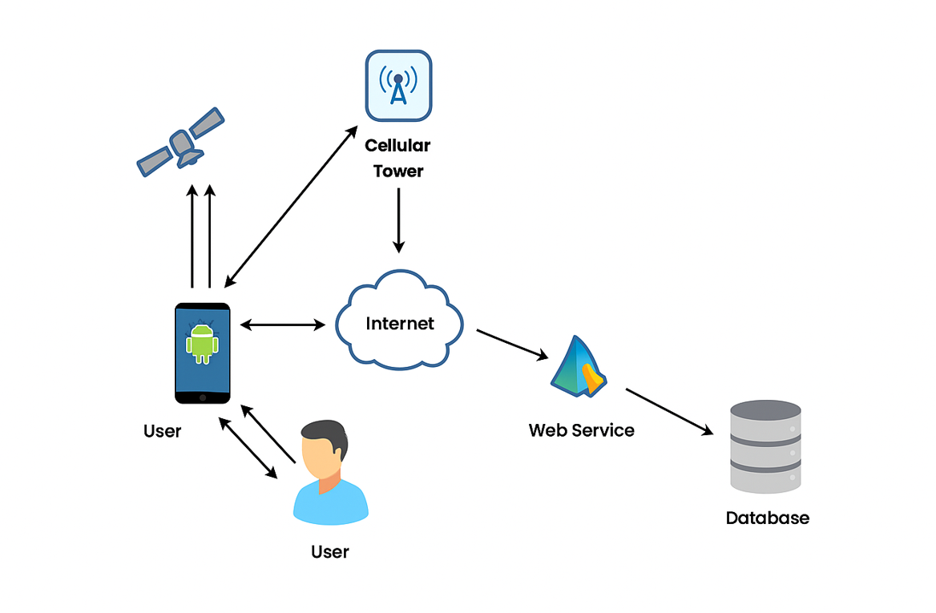
Fig. 3.1 Existing Diagram

CHAPTER 4
PROBLEMS IDENTIFIED
Despite the increasing growth of tourism and digital platforms, existing systems for booking tourist guides still face several limitations. These challenges reduce efficiency, affect user satisfaction, and create gaps in service delivery. The key problems identified in the current guide booking environment are as follows:
1. Lack of a Centralized Guide Booking Platform
Most tourists rely on multiple sources local agencies, informal contacts, or travel operators to hire guides. There is no unified platform where tourists can easily browse, compare, and book verified guides. This leads to inconvenience, inconsistency in service quality, and difficulty in planning tours efficiently.
2. Difficulty in Finding Verified and Trustworthy Guides
Current systems lack authentication or verification mechanisms. Tourists often cannot confirm the credibility, experience, or specialization of a guide before hiring. This increases the risk of fraud, misinformation, and poor-quality service, thereby affecting the overall travel experience.
3. Limited Real-Time Availability and Scheduling
Traditional guide booking methods do not display real-time guide availability. Tourists must contact guides manually, which is time-consuming and may lead to booking conflicts. Similarly, guides have no proper platform to update their slots or manage schedules efficiently.
4. Poor Communication Between Tourists and Guides
Existing systems offer minimal or no in-app communication. Tourists depend on external communication channels like phone calls or messaging apps, which can cause misunderstanding about meeting points, timings, or special requirements. This lack of integrated communication reduces user satisfaction.
5. No Personalized Recommendations
Most platforms simply list guides without analysing tourist preferences. They fail to provide personalized suggestions based on factors like:
- Interests,
- Previous Travel History,
- Preferred Languages,
- Cultural Interests,
- Budget.
This absence of intelligent recommendation affects user engagement and makes guide selection more difficult.
6. Ineffective Review and Rating Systems
Even when reviews exist, they often lack validation or consistency. Some platforms allow outdated, biased, or fake reviews, making it hard for tourists to trust the guide ratings. Without a structured review analysis system, tourists cannot make informed decisions.
7. Limited Payment and Booking Security
Several platforms still rely on offline payments or unsecured online transactions. This creates issues such as payment fraud, mismatched booking confirmations, and poor financial transparency. A lack of secure digital payment gateways affects user trust.
8. Absence of Real-Time Location Tracking
Tourists often face challenges locating guides in crowded tourist spots. Existing systems do not integrate real-time GPS-based tracking, making coordination difficult. This can lead to delays, missed tours, and poor experience during travel.
9. Inadequate User Experience and Interface Design
Many guide booking systems focus on basic functionality and ignore:
- Simple Navigation,
- Modern Ui Design,
- Visual Clarity,
- Faster Search Options.
As a result, tourists find it confusing or difficult to explore guides, understand services, or complete bookings.
10. Lack of Support for Multi-Language Users
Tourism involves users from different regions and nationalities, but current platforms often provide content only in one language. The absence of multilingual support creates communication barriers and limits global accessibility.

CHAPTER 5
PROPOSED SYSTEM
The suggested online platform for the online tour guide booking system was created to get around the drawbacks of the manual approach and offer both tour guides and tourists a smooth and effective experience. With the use of this system, tourists may look through and reserve qualified tour guides according to their availability, experience, location, and user evaluations. Tour guides can sign up and make comprehensive profiles that highlight their qualifications, languages spoken, abilities, and previous customer reviews. To guarantee a seamless experience for every user, the platform provides automated notifications, safe online payment methods, and real-time booking. Through an intuitive interface, travelers can easily schedule services, compare options, and get verified information about guides. The system also includes an integrated feedback mechanism to enhance transparency and reliability. Administrators have the ability to oversee registrations, keep an eye on activity, and guarantee the caliber of services rendered. This suggested method uses technology to improve the trip experience, expedite the hiring of guides, and establish a trustworthy marketplace for matching guides with tourists.
ADVANTAGES OF PROPOSED SYSTEM
• Instant bookings based on availability are made possible by the system, guaranteeing effective scheduling free from delays or conflicts.
• Through an intuitive portal, travelers can search, compare, and reserve tour guides at any time and from any location, doing away with the necessity for in-person arrangements.
• Travelers are assisted in making well-informed decisions by comprehensive profiles that include verified credentials, languages spoken, areas of specialty, and user evaluations.

5.1 BLOCK DIAGRAM OF PROPOSED SYSTEM
A system architecture or systems architecture is the conceptual model that defines the structure, behavior, and more views of a system. An architecture description is a formal description and representation of a system, organized in a way that supports reasoning about the structures and behaviors of the system. System architecture can comprise system components, the externally visible properties of those components, the relationships (e.g. the behavior) between them. It can provide a plan from which products can be procured, and systems developed, that will work together to implement the overall system. There have been efforts to formalize languages to describe system architecture, collectively these are called architecture description languages (ADLs).

Various organizations define systems architecture in different ways, including:
• An allocated arrangement of physical elements which provides the design solution for a consumer product or life-cycle process intended to satisfy the requirements of the functional architecture and the requirements baseline.
• Architecture comprises the most important, pervasive, top-level, strategic inventions, decisions, and their associated rationales about the overall structure (i.e., essential elements and their relationships) and associated characteristics and behavior.
• If documented, it may include information such as a detailed inventory of current hardware, software and networking capabilities; a description of long-range plans and priorities for future purchases, and a plan for upgrading and/or replacing dated equipment and software
• The composite of the design architectures for products and their life-cycle processes.

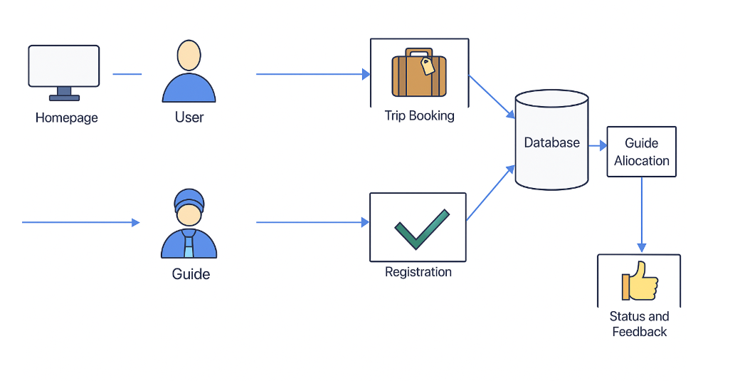
Fig. 5.1 Proposed Diagram

CHAPTER 6
SYSTEM DESIGN

The system design of the Online Tourist Guide Booking System outlines the structured flow of operations, architectural interactions, and the coordination between different modules. It visually explains how a tourist can browse available guides, check real-time availability, book a guide, make secure payments, and receive booking confirmation. The system contains multiple components such as the User Module, Guide Module, Booking Module, Authentication Module, Payment Module, Notification Module, and Database Module.

6.1 USECASE DIAGRAM
The use case diagram for the Online Tourist Guide Booking System explains how different users interact with the platform. Tourists can register, log in, search for guides, view profiles, check availability, book guides, and make payments. Guides update their availability, manage booking requests, and maintain their profiles. The admin monitors users, verifies guide details, and manages system data. This diagram helps visualize all major functions performed by each actor and clearly defines the scope of interactions within the system.
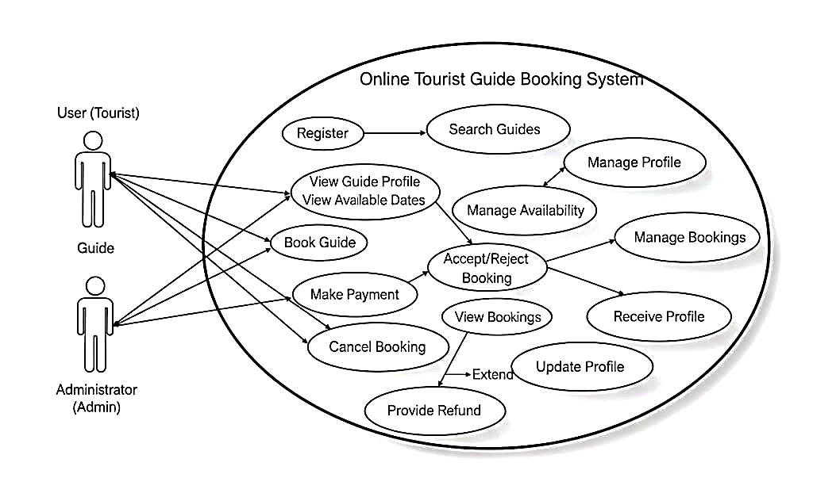
Fig. 6.1 Use case Diagram
6.2 CLASS DIAGRAM
The class diagram shows the main structural components of the system. It includes classes such as User, Guide, Tourist, Booking, Payment, and Review. Each class contains specific attributes and methods relevant to its role, and relationships between these classes show how data flows within the system. The diagram highlights how user information, guide details, booking records, and payments are organized, ensuring a modular and maintainable design.
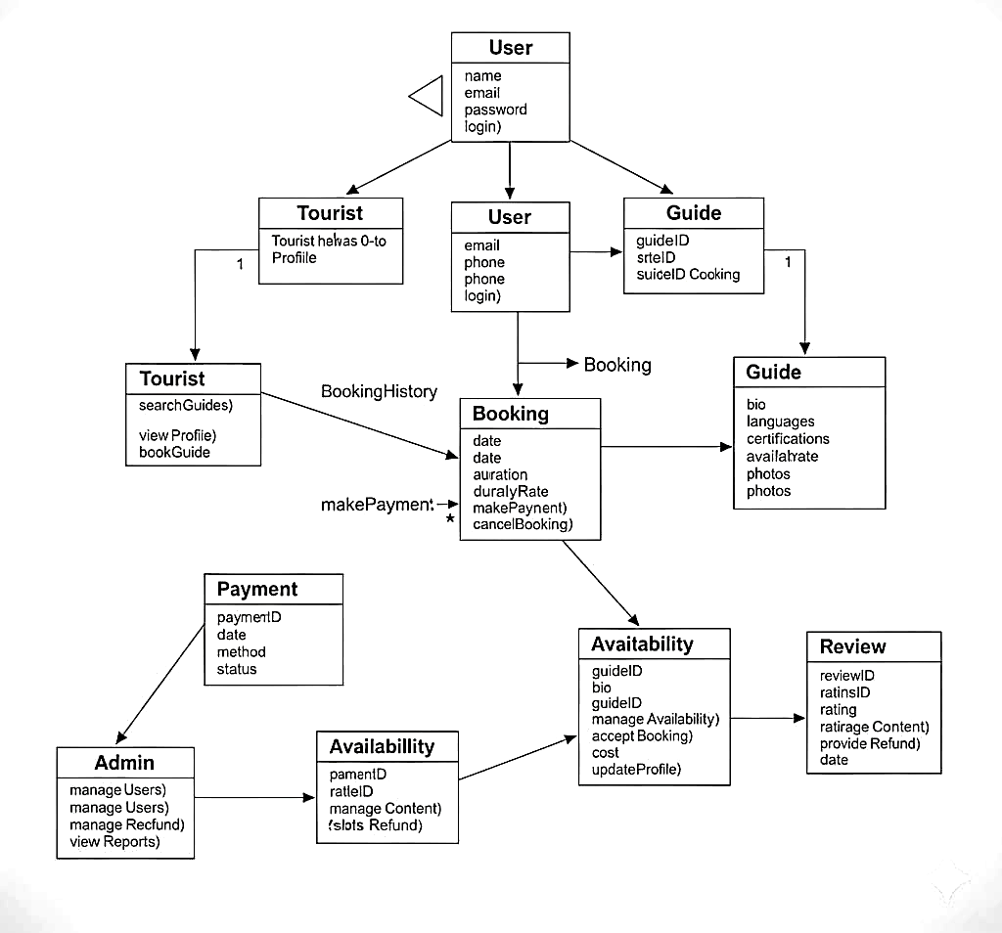
Fig. 6.2 Class Diagram

6.3 SEQUENCE DIAGRAM
The sequence diagram represents the step-by-step flow when a tourist books a guide. The user selects a guide, requests booking, and the system checks the guide’s availability. Once the booking is confirmed, the user proceeds with payment, and the system updates the booking status. The final confirmation is then displayed to the user. This diagram clearly shows how each component communicates during the booking process.

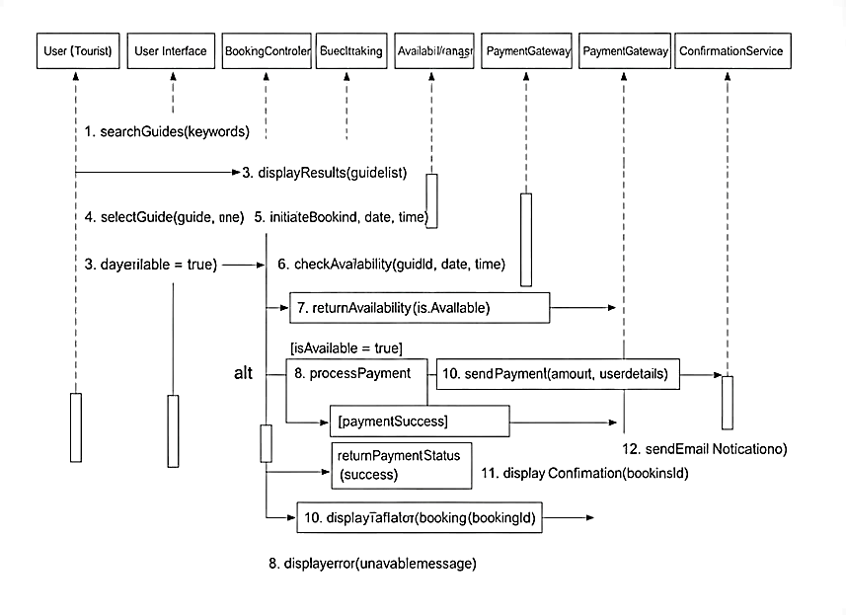
Fig. 6.3 Sequence Diagram

6.4 COMPONENT DIAGRAM
The component diagram outlines the main functional modules of the system, including the User Interface, Authentication Module, Guide Management Module, Booking Module, Payment Module, Review Module, and Database Module. Each component performs a specific function, and together they support searching, booking, payment processing, and guide management. The diagram shows how each module is connected and how data flows between them.

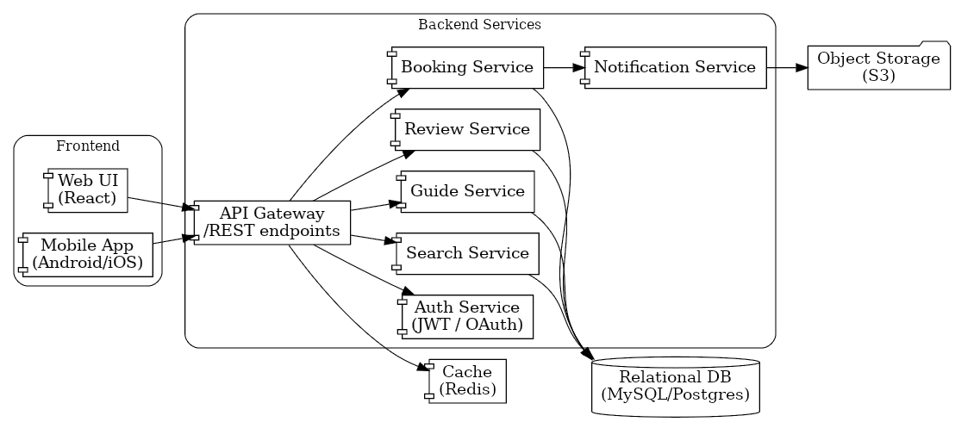
Fig. 6.4 Component Diagram

6.5 DEPLOYMENT DIAGRAM
The deployment diagram illustrates how the system is deployed across different hardware nodes. The user interacts through a mobile or web device, which connects to the web server. The application server handles business logic such as booking, payments, and guide management, while the database server stores all records. Additional external services like payment gateways support secure transactions. This setup ensures smooth operation and efficient data processing.

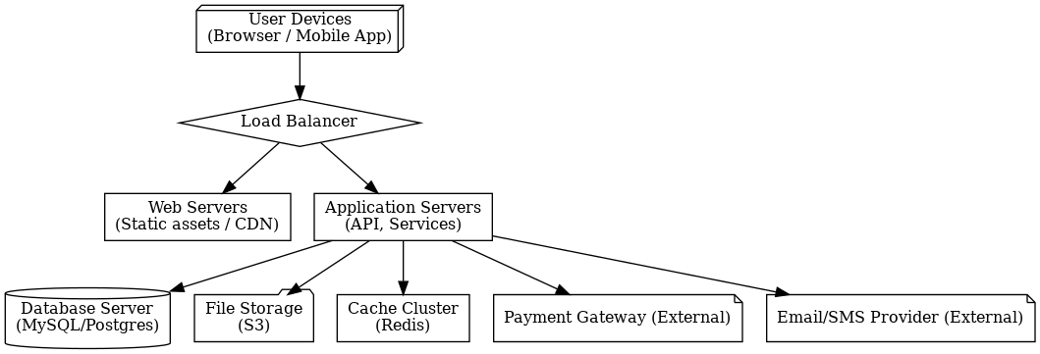
Fig. 6.5 Deployment Diagram

6.6 ARCHITECTURE DIAGRAM
The architecture diagram describes the system’s flow across the presentation, business, and data layers. The user interacts through the front-end interface, while the back-end handles processes like authentication, booking, and reviews. The database layer stores all the necessary information. External services such as payment processing and notifications support the overall functionality. This diagram provides a clear overview of how the system components work together.
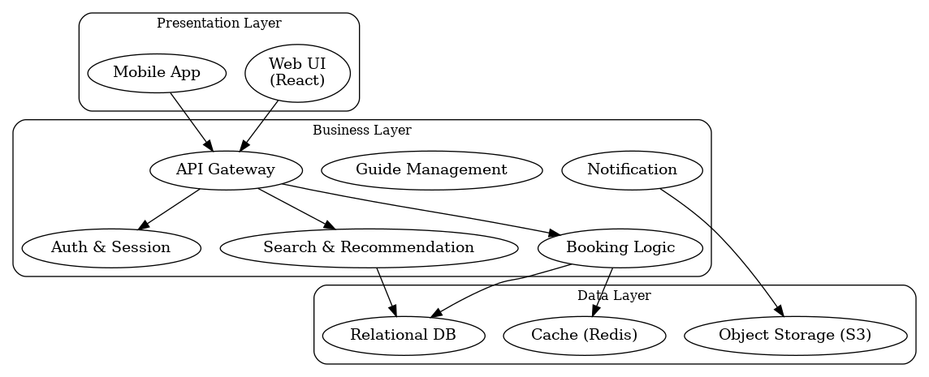

Fig. 6.6 Architecture Diagram

CHAPTER 7
SYSTEM REQUIREMENTS

7.1 Hardware Requirements
• Processor : Dual core processor 2.6.0 GHZ
• RAM GHZ : 4GB
• Hard disk : 320 GB
• Compact Disk : 650 Mb
• Keyboard : Standard keyboard

7.2 Software Requirements
• Operating system : Windows OS
• Front End : PHP
• Back end : MYSQL Server
• Tool : Macromedia Dreamweaver 8
Macromedia Dreamweaver 8
Macromedia Dreamweaver 8 is a powerful web development tool that allows users to create, design, and manage websites visually and through code. It offers a WYSIWYG (What You See Is What You Get) interface, making it easier for beginners to create web pages. Advanced users can switch to code view to write HTML, CSS, and JavaScript directly. Dreamweaver 8 provides features listed management, template creation, CSS editing, and integration with databases and servers, making it a comprehensive tool for web development.

CHAPTER 8
SYSTEM IMPLEMENTATIONS

8.1 LIST OF MODULES

• User Registration & Authentication Module

• Guide Profile Management Module

• Tour Management Module

• Booking & Reservation System Module

• Review and Rating Module

8.1.1 User Registration & Authentication Module
User Register
The purpose of the User Registration Module is to make it easier for new users to be onboarded into the system. With the use of this module, passengers can register by entering their name, email address, phone number, and password.
Login
One crucial element that gives registered users safe access to the system is the User Login Module. Users can use their login information, such as a username and password or a registered email address, to access this module. To authenticate the user and provide access to their account, the system compares the information they have provided with data that has been stored.

8.1.2 Guide Profile Management Module
Login
Administrators can access and control the system's backend features through the Admin Login Module, a secure gateway. By employing a secure username and password, the administrator can authenticate themselves through this module, guaranteeing that only authorized staff can use the administrative capabilities.
Add Guide Details
Administrators can control and modify tour guides' profiles in the system with the Add Guide Details Module. The administrator can provide detailed information about each guide using this module, such as their name, contact information, areas of expertise, languages spoken, certifications, availability, and any other qualifications that improve their profile.
View Booking Details
Tour guides can access and manage their booking schedules with ease thanks to the Guide Can View Booking Details Module. Guides can examine confirmed booking details, such as passenger details, tour dates, times, and destinations, using this section. Guides can effectively arrange their schedules by checking the status of upcoming reservations.
Accept/ reject
Tour guides may efficiently handle their booking requests with the help of the Accept/Reject User Booking Module. Depending on their availability and personal preferences, guides can choose to accept or reject these reservations. The system contacts the passenger and confirms the arrangement when a booking is approved, updating the itinerary to reflect the new reservation. The system makes sure the booking slot is open for other possible requests and notifies the traveler if a guide decides to deny a request.
8.1.3 Tour Management Module
The tour management module in an online tourist guide booking system allows for the creation and management of tours, including defining tour details like name, description, duration, itinerary, meeting point, pricing, and available dates and times. It also enables the categorization of tours based on themes, activity levels, and destinations. The module facilitates guide allocation based on their qualifications, experience, language skills, and availability. It integrates with a secure payment gateway for online bookings and offers real-time tracking of tour groups and guides using GPS technology. Additionally, it incorporates a review and rating system to collect customer feedback and improve tour offerings.
8.1.4 Booking & Reservation System Module
View Guide
Travelers can browse and get detailed information about available tour guides using the User Can View Guide Details Module. Each guide's name, areas of expertise, languages spoken, credentials, and experience are all included in this module's comprehensive profiles.
Booking
The Guide Can Be Reserved by the User The purpose of the module is to make it simple for tourists to plan and reserve excursions with the guides of their choice. This module allows customers to select a guide from the list of available alternatives, go over the guide's profile, and decide on their chosen tour dates and hours. The system handles the request and modifies the guide's itinerary to reflect the new booking as soon as the booking details are finalized.
Cancel Booking
The booking may be cancelled by the user. By offering the ability to cancel excursions if needed, the module gives tourists control over their reservations. Users can browse their upcoming reservations and choose which one they want to cancel with ease thanks to this module.

View Booking

Travelers can access and examine their past and present booking information by using the User Can View Booking Details Module. The name of the guide, the tour date, time, place, and length, as well as any extra notes or special requests made during the booking process, are all displayed in full in this module.

8.1.5 Review and Rating Module
The review and rating module is a crucial component of an online tourist guide booking system. It allows users to provide valuable feedback on their tour experiences. Users can rate the tour on a scale of 1 to 5 stars, with 5 being the highest. Additionally, users can write detailed reviews, sharing their thoughts on various aspects of the tour, such as the guide’s knowledge, the itinerary, the overall experience, and more. For example, a user might write, “★★★★★ The tour guide was incredibly knowledgeable and passionate. The tour itself was well organized and offered stunning views. Highly recommend!” These reviews and ratings help 14 other users make informed decisions when booking tours and provide valuable insights to tour operators to improve their services.

CHAPTER 9
RESULT AND DISCUSSION
9.1 RESULT AND DISCUSSION
The Online Tourist Guide Booking System successfully enables tourists to search for guides, check their availability, and complete bookings in a simple and efficient manner. The system allows users to browse guide profiles, view expertise, languages spoken, pricing, and ratings, and then proceed with secure bookings. When users perform actions such as searching for guides in a specific location or confirming a booking, the system processes the request instantly and retrieves accurate results from the database. Guide confirmations, booking details, and notifications are displayed clearly on the interface, ensuring smooth interaction. The successful execution of search, booking, payment, and review functionalities validates the reliability and effectiveness of the system. Overall, the results demonstrate that the application can handle real-time user requests with high accuracy and provides a convenient platform for both tourists and guides.
9.2 Performance of Guide Search and Matching
The system demonstrates strong performance in retrieving guide details and matching them with user preferences. The search module efficiently filters guides based on criteria such as location, language, expertise, and availability. The optimized database queries ensure that results are returned quickly, even when multiple filters are applied. Easy navigation and accurate matching help tourists choose suitable guides without confusion. The system also maintains fast response times, making it capable of supporting real-time usage during peak tourism periods. This performance verifies that the system is effective in handling dynamic search requests and providing relevant recommendations to users.

9.3 Booking Execution and Response Handling
During testing, the booking module performed flawlessly in processing tourist booking requests and updating the system in real time. When tourists send a booking request, the application verifies guide availability, stores booking records, and notifies the guide automatically. Confirmed and rejected bookings are clearly reflected on the tourist’s dashboard. Payment operations also execute smoothly, with proper transaction status updates. The system’s error-handling capability ensures that invalid bookings, unavailable dates, or missing details are detected and communicated through meaningful messages. Overall, the booking and execution flow is stable, accurate, and dependable.

9.4 User Interface Output and Interaction
The user interface provides a clean and user-friendly experience for both tourists and guides. Tourists can easily search, filter, and book guides, while guides can manage their schedules with minimal effort. Booking confirmations, guide details, and notifications are presented in well-organized formats, allowing users to understand system responses quickly. The straightforward design makes the system accessible even to individuals without technical knowledge. The interface behavior ensures that users can navigate the system intuitively and complete all tasks efficiently, confirming the usability and simplicity of the platform.

9.5 Comparison with Traditional Guide Booking Methods
Compared to manual or offline guide booking processes, the Online Tourist Guide Booking System significantly reduces time, effort, and dependency on intermediaries. In traditional methods, users need to visit agencies or rely on local contacts, which often leads to uncertainty and limited choices. This system allows tourists to search, compare, and book guides instantly through a single platform. The availability of reviews and ratings helps users make informed decisions, and secure online payments eliminate the risk of overcharging or fraud. The results clearly show that the proposed system provides a faster, more convenient, and transparent solution than conventional guide booking methods.

9.6 System Accuracy and Limitations
While the system performs accurately for most typical operations, some limitations were observed. If multiple guides share similar names or details, the search module may require more advanced filters to avoid confusion. Additionally, real-time location features and automated matching algorithms could be further improved to enhance personalization. In cases where internet connectivity is poor, system responsiveness may temporarily slow down. However, these limitations do not affect the core performance of the system and highlight potential enhancements for future versions. Overall accuracy remains high across search, booking, and payment processes.

9.7 Overall Discussion
The results confirm that the Online Tourist Guide Booking System effectively simplifies the interaction between tourists and guides by providing a structured, digital, and user-friendly booking experience. Through modules such as Search, Booking, Payment, and Reviews, the system ensures smooth and reliable operation from start to finish. Fast processing, intuitive design, real-time updates, and proper error handling contribute to a positive user experience. The successful implementation demonstrates the system’s potential as a practical solution for modern tourism needs, supporting both customers and guides with efficient and transparent service.

CHAPTER 10
CONCLUSION AND FUTURE WORK
10.1 CONCLUSION
By improving efficiency, transparency, and user-friendliness, the Tourist Guide Booking System initiative seeks to transform the relationship between tourists and tour guides. The solution solves the problems that both tourists and guides encounter with manual procedures by digitizing and automating essential tasks including guide registration, booking, and payment. The project effectively improves accessibility to verified guide profiles, expedites the booking process, and offers a platform for direct and safe communication. In addition to making travel planning easier for travelers, it also helps tour guides reach a wider audience and efficiently manage their schedules. In the end, this system promotes better planning, better service, and a more pleasurable trip, making it a useful instrument in the travel sector.

10.2 FUTURE ENHANCEMENTS
Future enhancements for the Tourist Guide Booking System could include integrating advanced features such as AI-driven personalized tour recommendations, which would suggest guides and itineraries based on user preferences and past activities. Implementing a multilingual interface would make the system more accessible to a global audience, catering to travellers from diverse backgrounds. Adding a real-time tracking feature for tours, where users can track the guide’s location, would improve safety and provide peace of mind to travellers. Additionally, incorporating a review and rating system that allows users to leave detailed feedback would help maintain service quality and assist new users in making informed decisions.
Further enhancements could involve enabling dynamic pricing models, where guide charges adjust based on demand, time of day, or special seasons. Integration with local tourism APIs could allow automatic suggestions of nearby attractions, events, and cultural activities. A chat support system, either AI-based or human-assisted, could provide instant help to tourists during booking or during their trip. Implementing secure digital identity verification for guides would increase trust and platform credibility. Adding features like offline booking support, guide availability analytics, and push notifications for reminders or updates would further improve functionality.
In the long term, the system could evolve into a complete smart travel assistant by integrating AR-based navigation, voice-assisted search, and personalized trip planning tools, making the platform more intelligent, interactive, and valuable for travellers and guides alike.

APPENDIX – A
SOURCE CODE
<!DOCTYPE html>
<html class="wide wow-animation" lang="en">
<head>
<title>Home</title>
<meta charset="utf-8">
<meta name="viewport" content="width=device-width, height=device-height, initialscale=1.0">
<meta http-equiv="X-UA-Compatible" content="IE=edge">
<script src="/cdn-cgi/apps/head/3ts2ksMwXvKRuG480KNifJ2_JNM.js"></script>
<link rel="icon" href="images/favicon.ico" type="image/x-icon">
<link rel="stylesheet" type="text/css"
href="//fonts.googleapis.com/css?family=Oswald:200,300,400,500,700%7CMontserrat:400,5 00,600">
<link rel="stylesheet" href="css/bootstrap.css">
<link rel="stylesheet" href="css/fonts.css">
<link rel="stylesheet" href="css/style.css">
<script src="https://kit.fontawesome.com/1fb451dce7.js" crossorigin="anonymous"></script>
<style>
.ie-panel {
display: none;
background: #212121;
padding: 10px 0;
box-shadow: 3px 3px 5px 0 rgba (0, 0, 0, .3);
clear: both;
text-align: center;
position: relative;
z-index: 1;
}
html.ie-10 .ie-panel,
html.lt-ie-10 .ie-panel {
display: block;
}
</style>
</head>
<body>
<div class="ie-panel"><a href="https://windows.microsoft.com/en-US/internetexplorer/"><img
src="images/ie8-panel/warning_bar_0000_us.jpg" height="42" width="820"
alt="You are using an outdated browser. For a faster, safer browsing experience, upgrade for free today."></a>
</div>
<div class="preloader">
<div class="preloader-body">
<div class="cssload-container">
<div class="cssload-speeding-wheel"></div>
</div>
<p>Loading...</p>
</div>
</div>
<div class="page">
<header class="section page-header">
<! --RD Navbar-->
<div class="rd-navbar-wrap">
<nav class="rd-navbar rd-navbar-classic" data-layout="rd-navbar-fixed" data-smlayout="rd-navbar-fixed"
data-md-layout="rd-navbar-fixed" data-md-device-layout="rdnavbar-fixed"
data-lg-layout="rd-navbar-static" data-lg-device-layout="rd-navbar-static"
data-xl-layout="rd-navbar-static" data-xl-device-layout="rd-navbar-static"
datalg-stick-up-offset="46px" data-xl-stick-up-offset="46px" data-xxl-stick-up-offset="46px"
data-lg-stick-up="true" data-xl-stick-up="true" data-xxl-stick-up="true">
<div class="rd-navbar-collapse-toggle rd-navbar-fixed-element-1"
data-rdnavbar-toggle= “. rd-navbar-collapse"><span></span></div>
<div class="rd-navbar-main-outer">
<div class="rd-navbar-main">
<! --RD Navbar Panel-->
<div class="rd-navbar-panel">
<! --RD Navbar Toggle-->
<button class="rd-navbar-toggle"
data-rd-navbar-toggle= “. rd-navbar-navwrap"><span></span></button>
<! --RD Navbar Brand-->
<div class="rd-navbar-brand">
<! --Brand-->
<h2 style="color: white">TOURIST GUIDE BOOK</h2>
</div>
</div>
<div class="rd-navbar-main-element">
<div class="rd-navbar-nav-wrap">
<ul class="rd-navbar-nav">
<li class="rd-nav-item active"><a class="rd-nav-link" href="index.php">Home</a>
</li>

<li class="rd-nav-item"><a class="rd-nav-link" href="guide.php">Guide</a></li>
<li class="rd-nav-item"><a class="rd-nav-link" href="user.php">User</a></li>
</li>
</ul>
</div>
<! --RD Navbar Search-->
<div class="rd-navbar-search">
</div>
</div>
</div>
</div>
</nav>
</div>
</header>
<! --Swiper-->
<section class="section swiper-container swiper-slider swiper-slider-1"
dataswiper='{"loop":"true","dataTouch”: false,"autoplay”: {"delay":5000}}'>
<div class="swiper-wrapper text-center">
<div class="swiper-slide context-dark" data-slide-bg="images/slider-1-slide-1.jpg">
<div class="swiper-slide-caption section-md">
<div class="container">
<div class="row justify-content-lg-center">
<div class="col-lg-8">
<div class="intro-box">
<div class="intro-box-floating-text">Journey</div>
<div class="intro-box-title"><span data-captionanimate="fadeInUp"
data-caption-delay="200">Exploring</span><span
data-captionanimate="fadeInUp" data-caption-delay="300">the world</span>
</div>
<div class="intro-box-video" data-caption-animate="fadeInUp"
data-caption-delay="400"><a
href="https://www.youtube.com/watch?v=7dTve2Hsl_0"
datalightgallery="item">Watch the video</a></div>
</div>
</div>
</div>
</div>
</div>
</div>
<div class="swiper-slide context-dark" data-slide-bg="images/slider-1-slide-2.jpg">
<div class="swiper-slide-caption section-md">
<div class="container">
<div class="row justify-content-lg-center">
<div class="col-lg-8">
<div class="intro-box">
<div class="intro-box-floating-text">Journey</div>
<div class="intro-box-title"><span data-captionanimate="fadeInUp"
data-caption-delay="200">Best</span><span data-captionanimate="fadeInUp"
data-caption-delay="300">Destinations</span></div>
<div class="intro-box-video" data-caption-animate="fadeInUp"
data-caption-delay="400"><a
href="https://www.youtube.com/watch?v=7dTve2Hsl_0"
datalightgallery="item">Watch the video</a></div>
</div>
</div>
</div>
</div>
</div>
</div>

</html>
APPENDIX – B
SCREENSHOTS

SAMPLE OUTPUT


Fig. B.1. Home Page

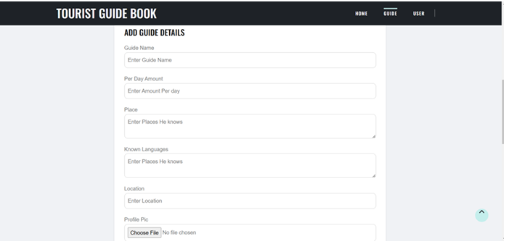

Fig. B.2. Guide Registration

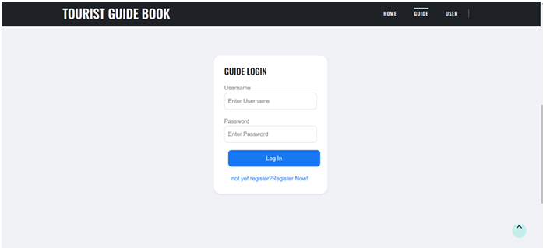
Fig. B.3. Guide Login

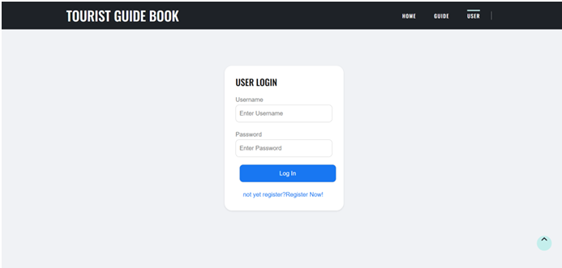

Fig. B.4. User Login

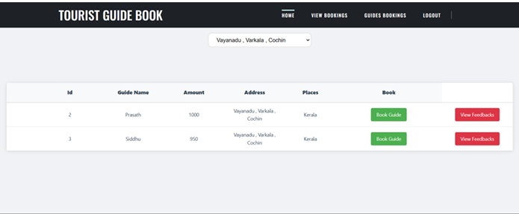
Fig. B.5. Book guide

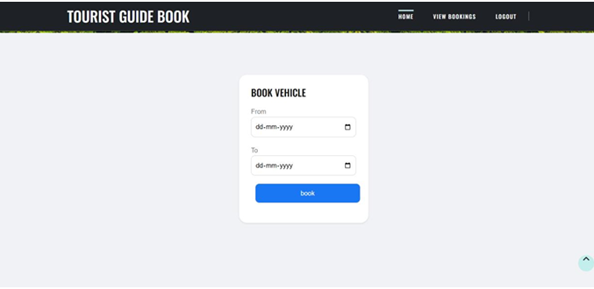
Fig. B.6. Reservation

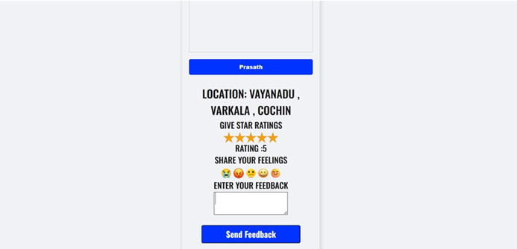
Fig. B.7. Feedback

REFERENCES

1.Chen, L., Zang, Y., & Wang, S. (2021). Big data for personalized tour guide recommendations. [Journal/Conference Name], [Volume], [Pages].
2. Zhang, P., & Lee, H. (2022). Social Media Integration in Guide Booking. Journal of Tourism Technology, 15(2), 123-145.
3. Singh, S., & Patel, A. (2018). Mobile-based tourist guide booking system. International Journal of Computer Science and Information Technology, 10(2), 123-145.
4. Patel, M., & Kaur, R. (2020). User Experience in Online Guide Booking Platforms. Journal of Tourism Management, 25(3), 150-165.
5. Kumar, V., & Agarwal, N. (2021). Impact of User Reviews in Guide Booking. Journal of E-Tourism, 18(1), 25-42.
6. Fernandez, M., & Martinez, J. (2020). Tourism Booking Systems: A Review of Technologies and Challenges. Tourism Review, 75(4), 420-435.
7. Lee, C.-H., & Chen, C.-C. (2017). A personalized tour recommendation system based on user preferences and social network analysis. Expert Systems with Applications, 80, 282-293.
8. Kim, H., & Lee, J. (2016). A mobile tour guide system using augmented reality and location-based services. Computers in Human Behavior, 57, 178-188.
9. Chen, C.-H., & Huang, S.-Y. (2015). A personalized tour recommendation system based on user preferences and social network analysis. Expert Systems with Applications, 42(1), 339-348.
10. Lu, Y., & Liu, Y. (2014). A personalized tour recommendation system based on user preferences and social network analysis. Expert Systems with Applications, 41(1), 43-53.
11. A. M. Aldossari and H. B. Mohd, "Online Booking System for Tourists: A Case Study of Saudi Arabia," Journal of Information Systems Research, vol.
12, no. 3, pp. 45-58, 2020. 12. J. O. Ferreira and P. M. Silva, "The Development of Online Booking Systems for Local Tourism," International Journal of Tourism Research, vol. 19, no. 2, pp. 225-240, 2019.
13. S. K. Sharma, "User-Centric Design of Tourist Booking Platforms," Journal of Travel Research, vol. 58, no. 5, pp. 733-746, 2018. 37
14. M. R. Brown, R. G. Smith, and L. T. Jones, "Enhancing Tourism through Digital Innovation: The Role of Online Booking Systems," Tourism Management Perspectives, vol. 34, pp. 100-115, 2022
15. K. T. Lee and C. W. Ng, "The Evolution of E-Tourism Platforms: Case Studies of Online Booking Systems," Journal of Hospitality and Tourism Technology, vol. 11, no. 4, pp. 673 688, 2020.
16. E. D. Roberts, "Adoption and Usage of Mobile Booking Systems for Tourism," Journal of Information Technology in Tourism, vol. 25, no. 1, pp. 15-32, 2021.
17. N. Q. Tran and M. T. Nguyen, "Designing a User-Friendly Online Tourist Guide Booking System," Vietnam Tourism Journal, vol. 10, no. 2, pp. 85-97, 2021.
18. P. A. Johnson, "Assessing the Effectiveness of Online Booking Platforms in the Hospitality Industry," Journal of Hospitality and Tourism Research, vol. 42, no. 4, pp. 581 598.
19. R. Singh and T. Kumar, "Online Booking Systems and Their Impact on Tourism Growth in India," International Journal of Tourism Sciences, vol. 15, no. 1, pp. 112-126, 2020.
20. F. G. Lopes and A. Martins, "A Comparative Study of Online Platforms for Tourism Management," Tourism Economics, vol. 27, no. 5, pp. 1052-1071, 2021.

